# Project Documentation

**Audio Book & Author**

# Project Overview

This project is about Audio Books and Authors. It analyses the Top rated books & author based on the ratings and sales using Excel and Power BI and improve business decisions.

# Tools Used

* + Microsoft Excel
  + Power BI

# Dataset

* + Source: [Audible_Data]
  + Data contains: [Audio Book Name, Author Name, Ratings, Total Playback Minutes, Price]

# Steps Followed

* + Cleaned data in Excel ( Removed Duplicates in Book Name, Created Total Playback Minutes)
  + Imported cleaned data into Power BI ( Date Format changed, Segregated Month & Year Audiobook Released )
  + Created New Table using DAX ( No of Books in each Language )
  + Using DAX created New Measures for No of Audio Books, Avg Book Price etc..
  + Built dashboards using Charts, Cards, and Buttons

# Key Insights

* + English Language has highest number of Audio Books followed by Hindi in 2nd place
  + Author Name “Noraroberts” leading the chart in Top 10 Author list by sales
  + Audio Book “The Decline And Fall Of the Roman Empire” rated based on the Highest Rating and Playback Minutes
  + Highest No of Audio Books released in the month of January

# Screenshots

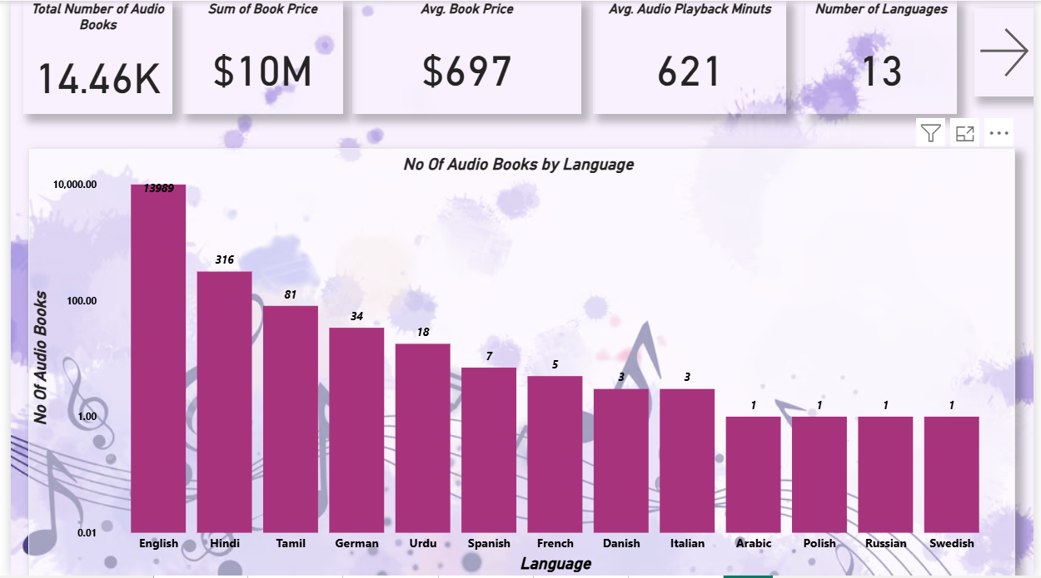

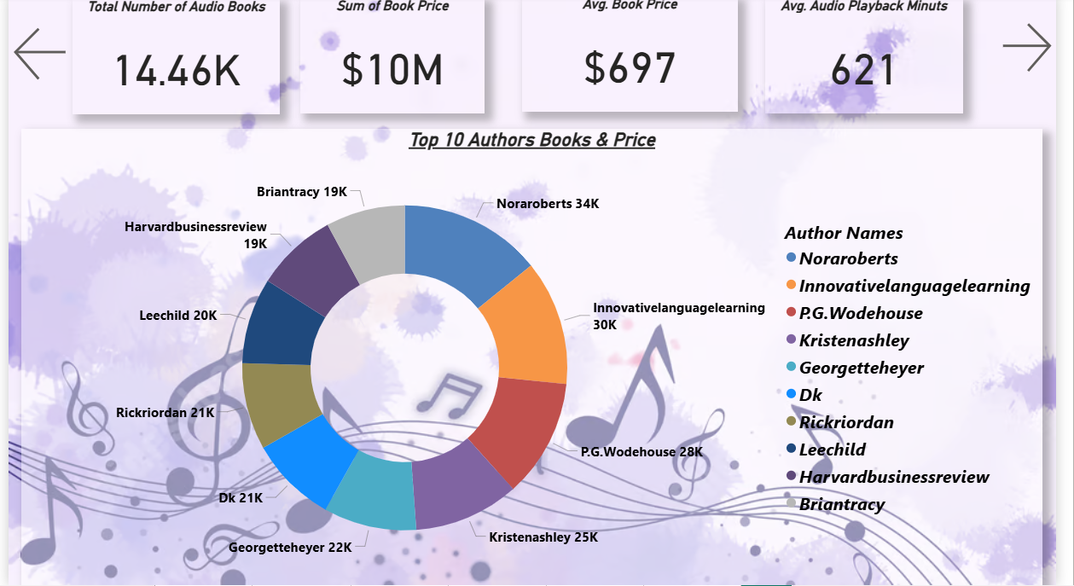

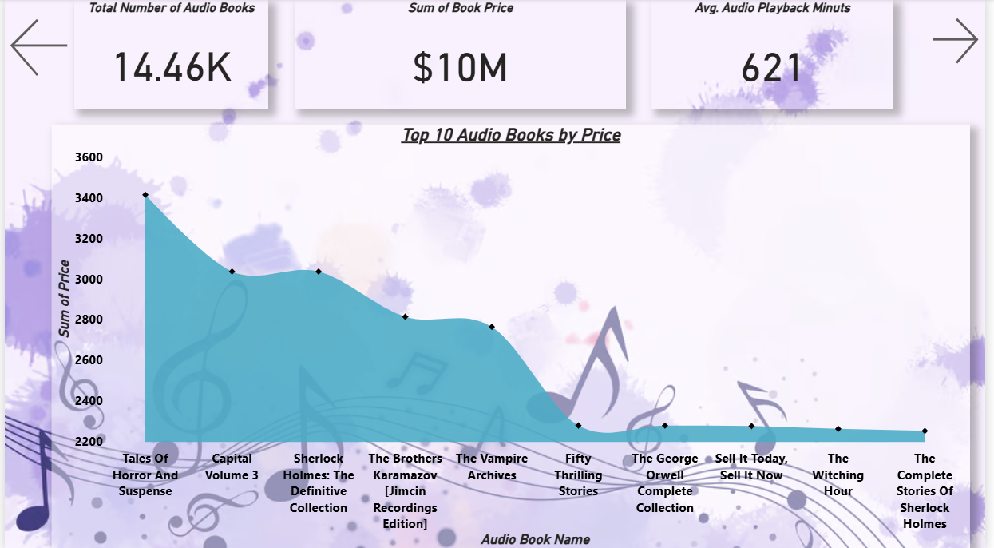

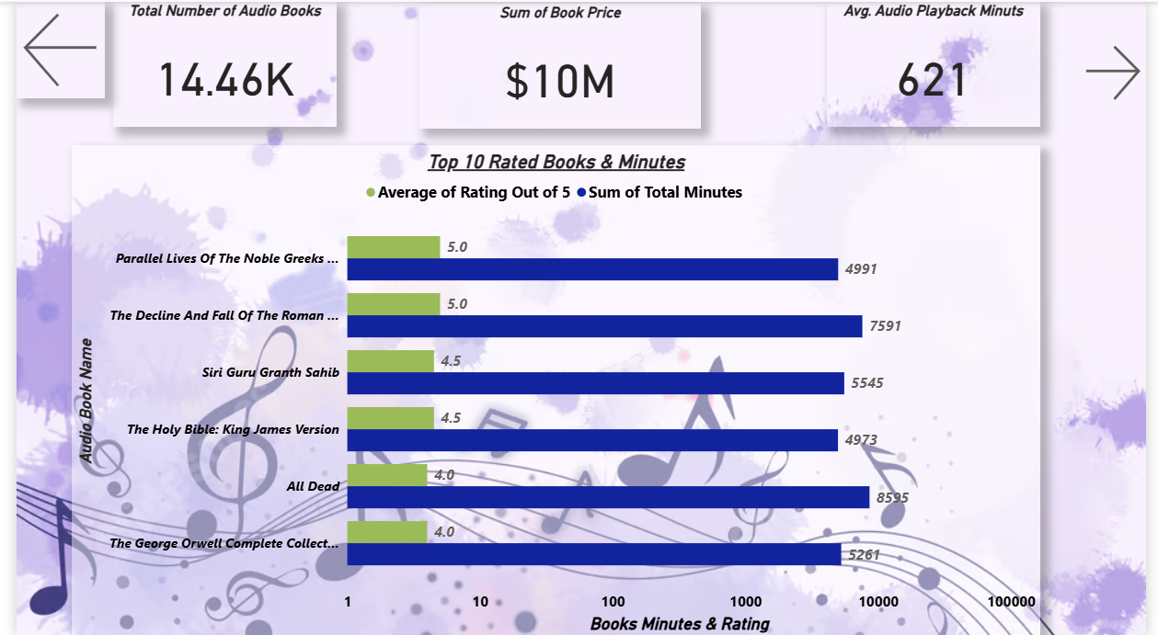

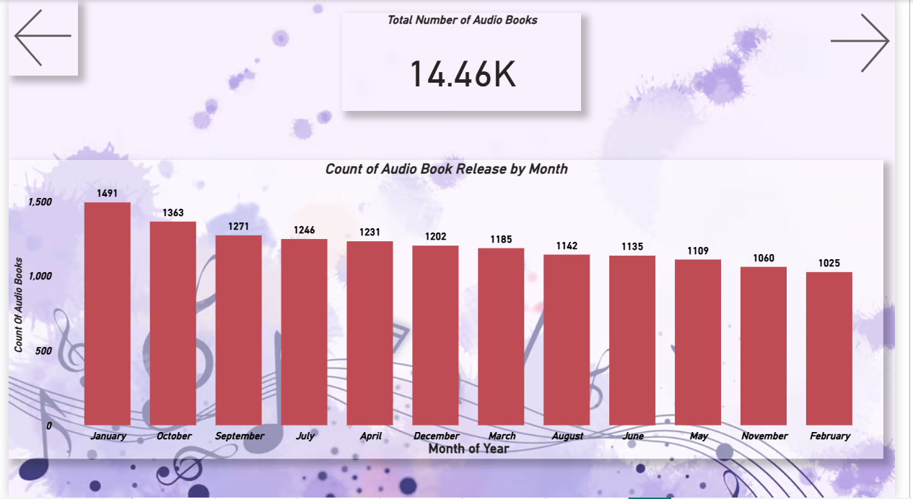

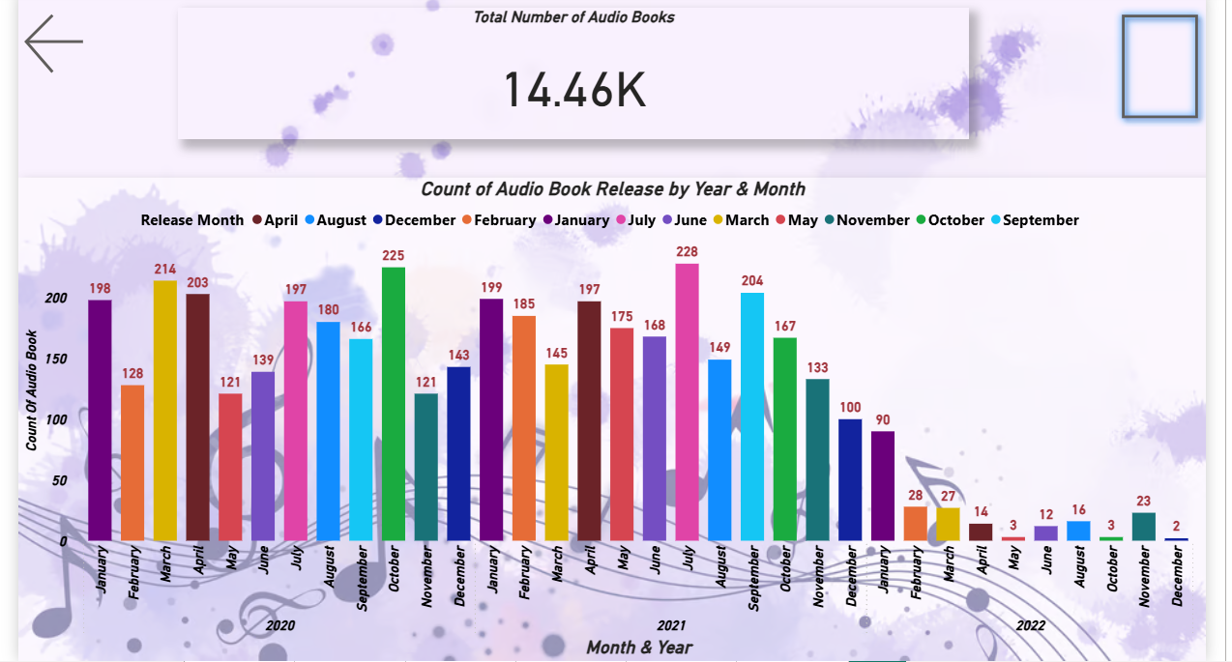

# Files Included

* + ‘audible_cleaned_github.xlsx’ – Cleaned data and basic analysis
  + ‘Audible_Final.pbix’ – Power BI dashboard
  + ‘README.md’ – Project description

# How to Use

* + Open ` audible_cleaned_github.xlsx ` to view the cleaned data.
  + Open ` Audible_Final.pbix ` in Power BI Desktop to explore the visuals.